Project 6 - Customer Services Request Analysis:

2.3 Plot for CityWise Complaints

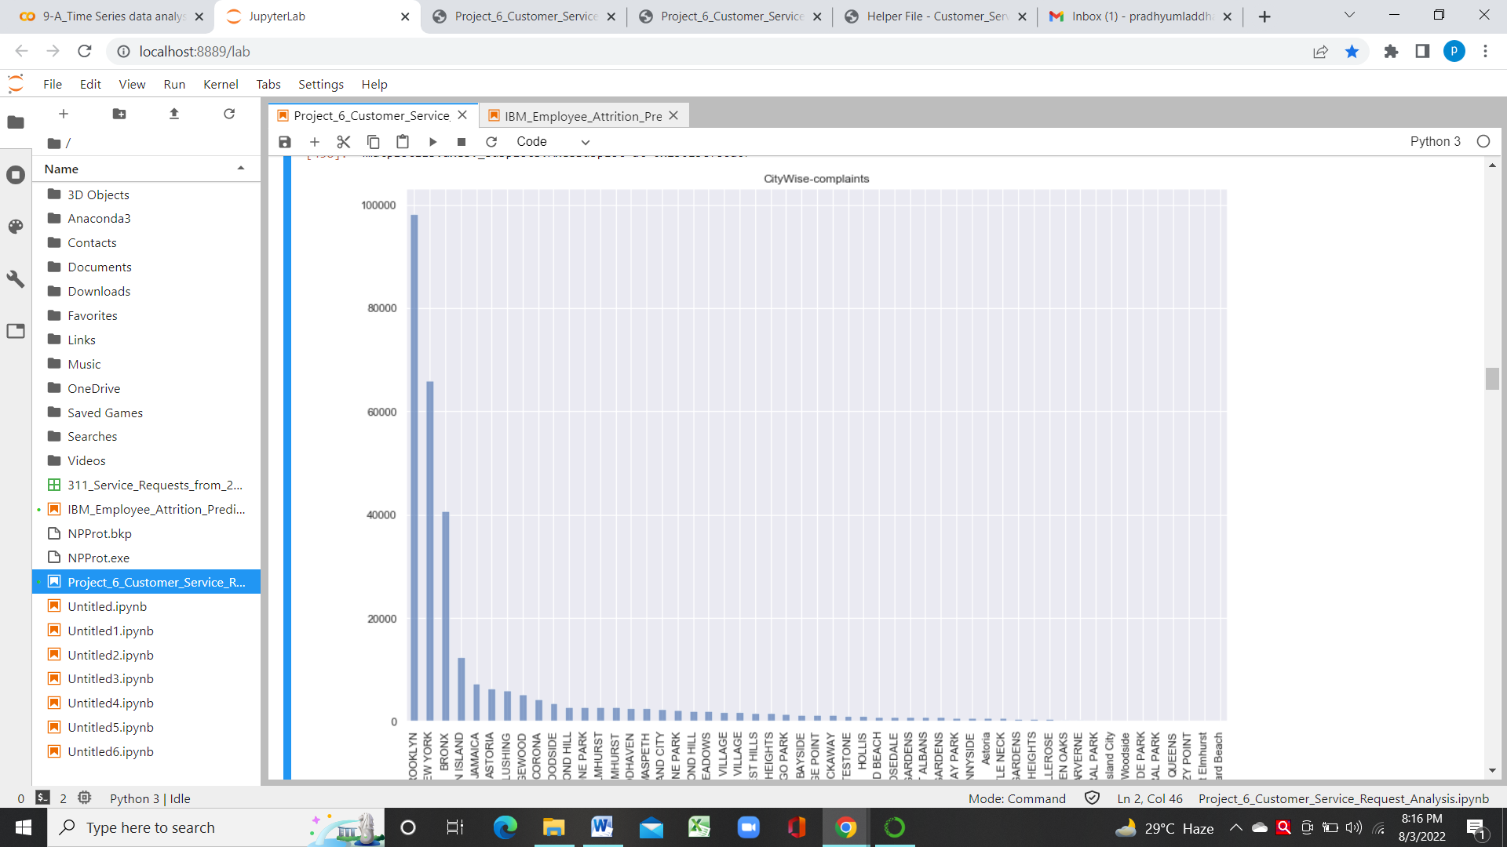

2.4 Scatter Plot and Hexbin Plot for Compalint Concentration across Brooklyn

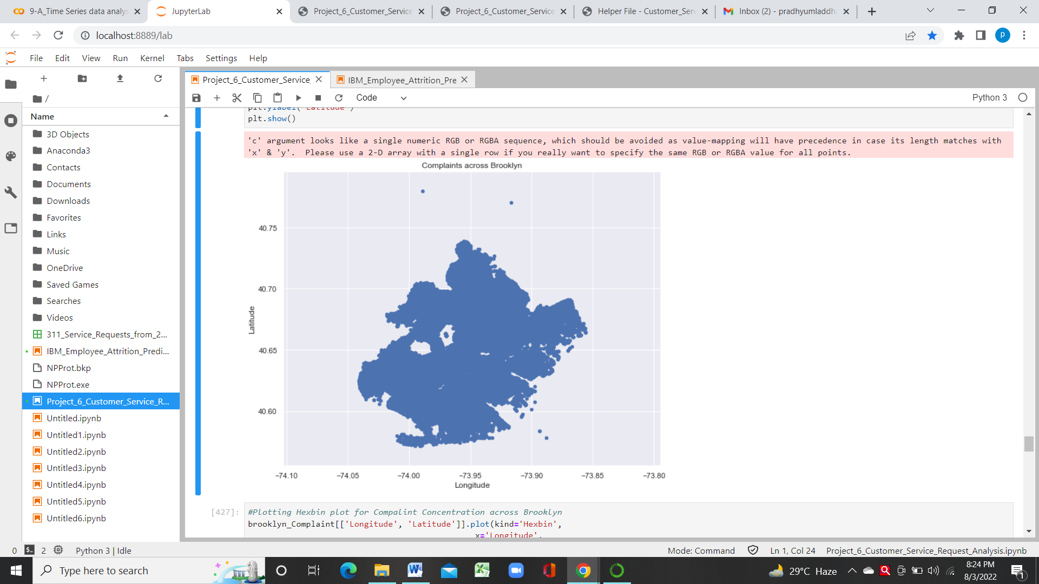

Hexbin Plot:

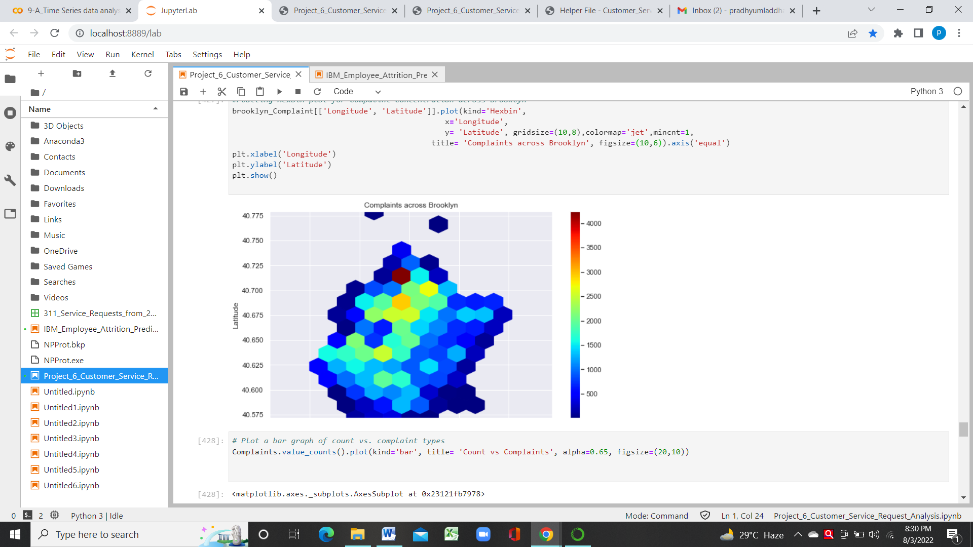

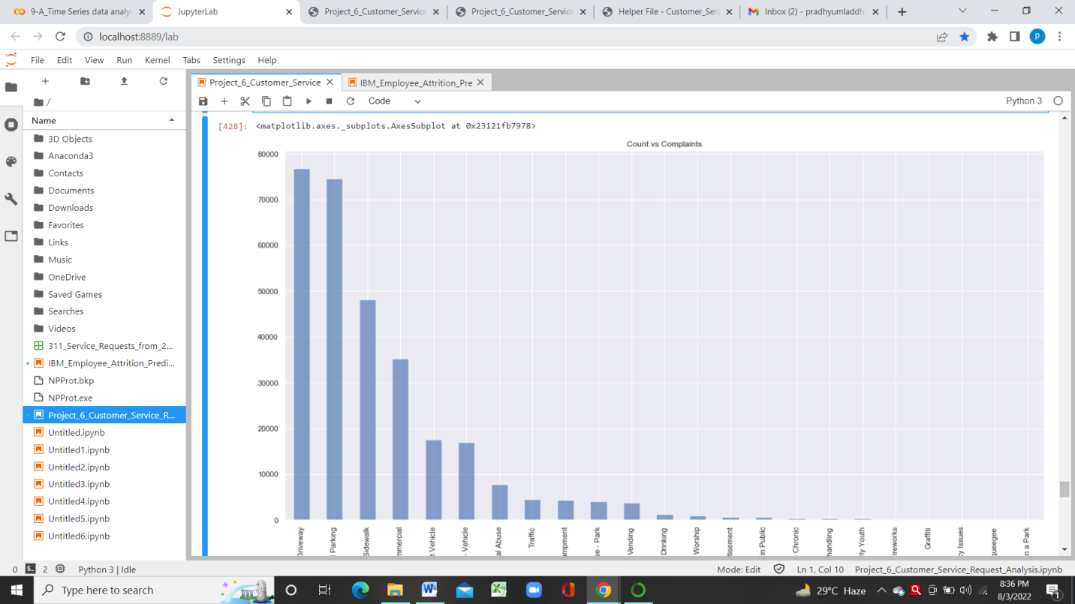3.1 Bar graph of count vs. complaint types

4. Visualizing major types of Complaints in cities

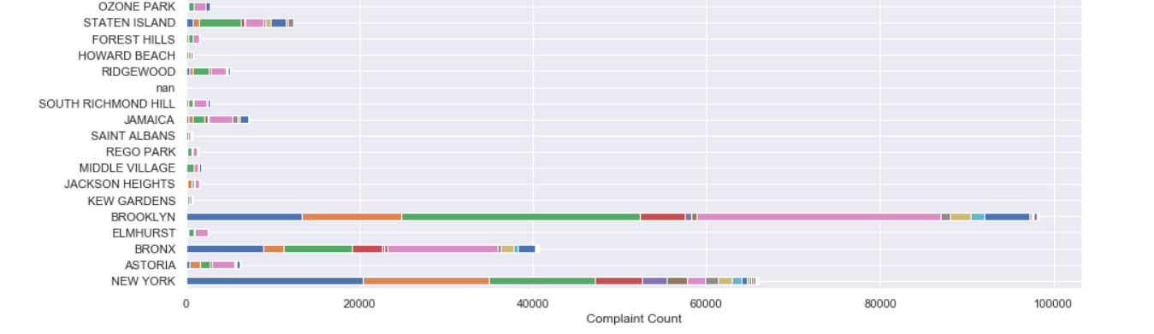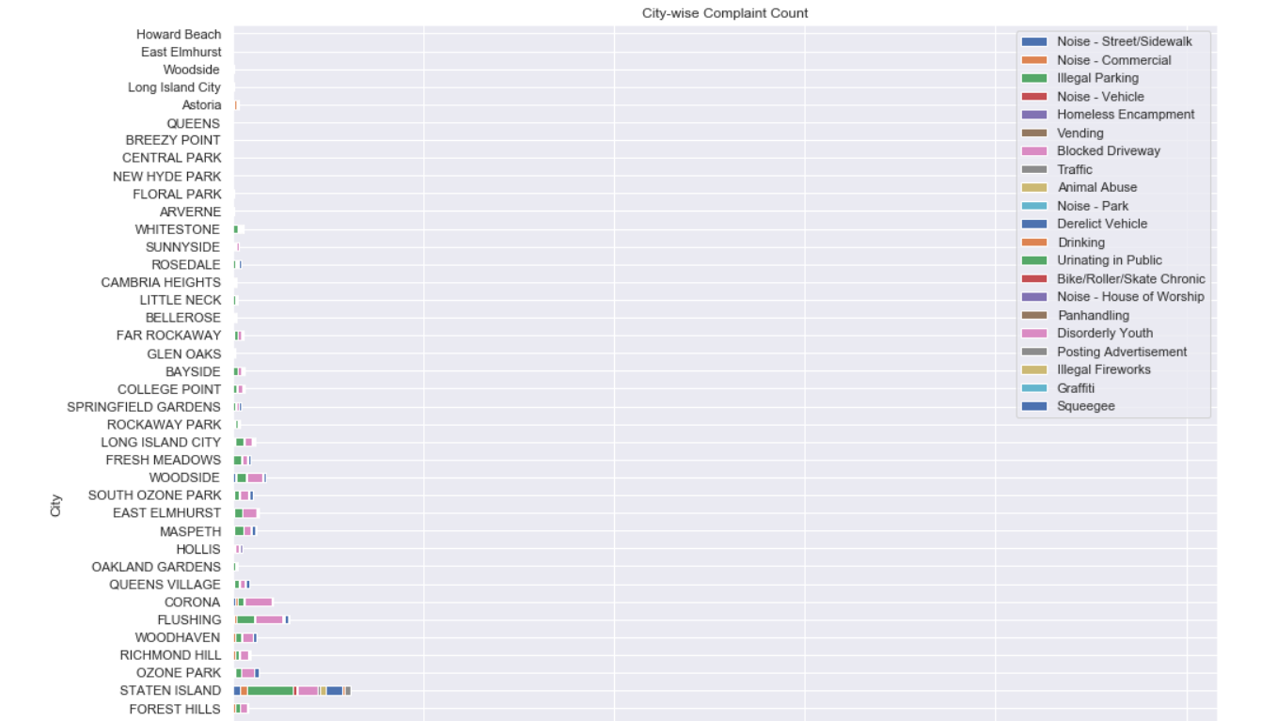

5. Visualizing graphically the average Request Closing Time

